openGauss AI特性创新实践课



华为技术有限公司

# 关卡一、openGauss数据安装及基本操作

openGauss数据安装及基本操作, 作业提交任务如下：

任务一：数据库状态验证

1. 查询数据库状态成功截图

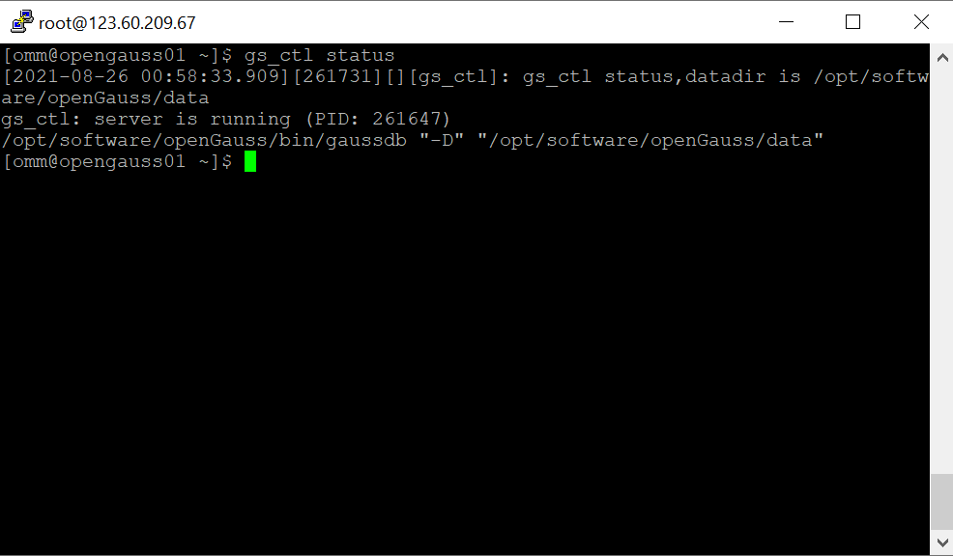

任务二：数据库服务进程验证

1. 查看数据库服务进程截图（包含数据库服务器的主机名）

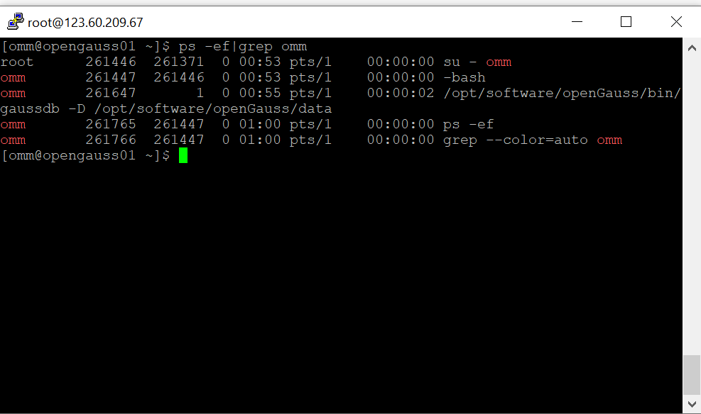

实验思考题：为什么需要通过源码编译，安装数据库？

By installing the database through source code the compilation parameters, as well as version, modules, etc. can be set easier than from preset installation file.

# 关卡二、openGauss数据导入及基本操作

任务一：数据初始化验证

1. 查询supplier表的行数，并将结果进行图：

select count(*) from supplier;;

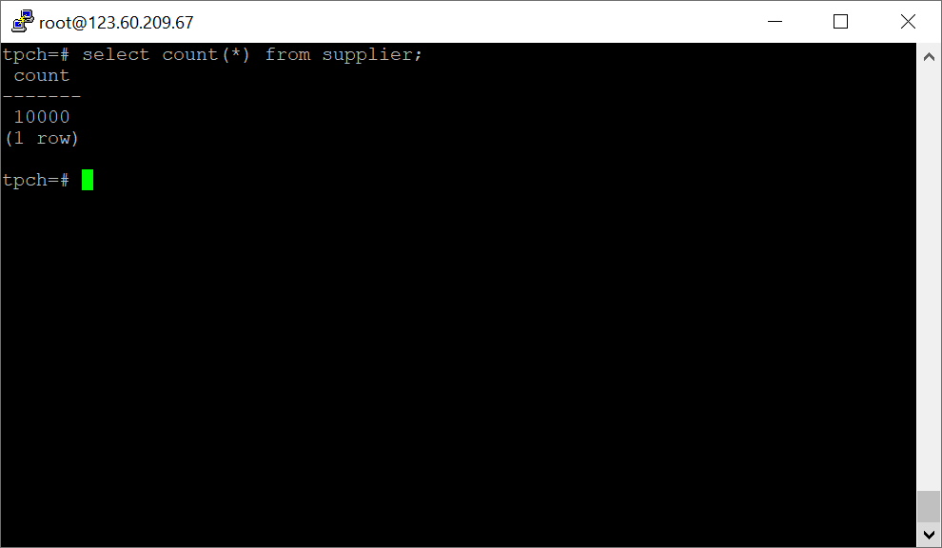

任务二：行存表与列存表执行效率对比

1. 2020年上半年litemall_orders行存表与litemall_orders_col列存表中的order_price的总和查询，并对比执行效率截图

select sum (order_price) from litemall_orders where add_date between '20200101' and '20200701';

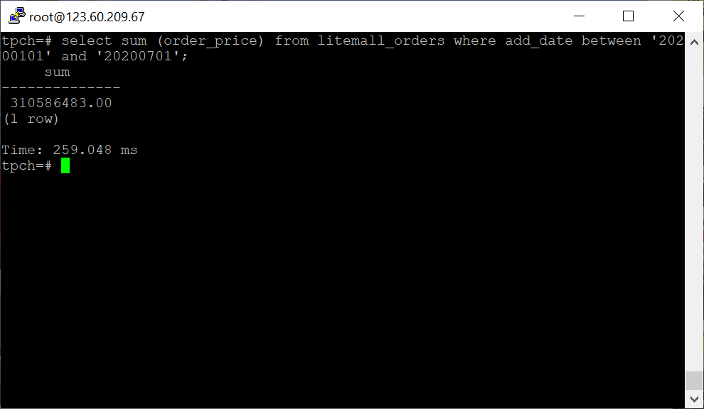

select sum (order_price) from litemall_orders_col where add_date between '20200101' and '20200701';

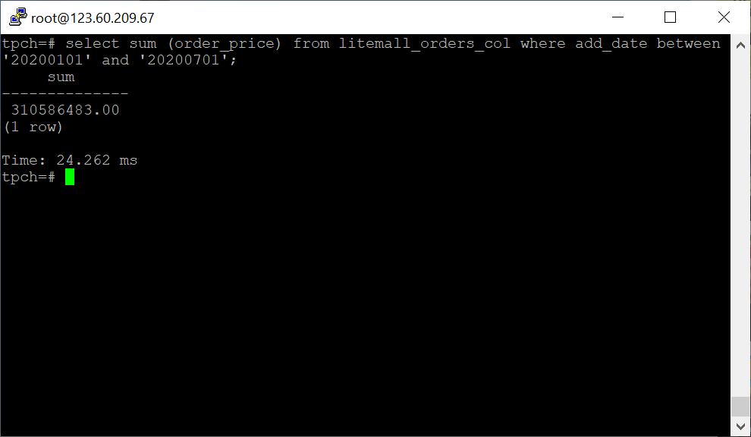

2. 2020年上半年litemall_orders行存表与litemall_orders_col列存表中的order_price的平均值查询，并对比执行效率截图

select avg (order_price) from litemall_orders where add_date between '20200101' and '20200701';

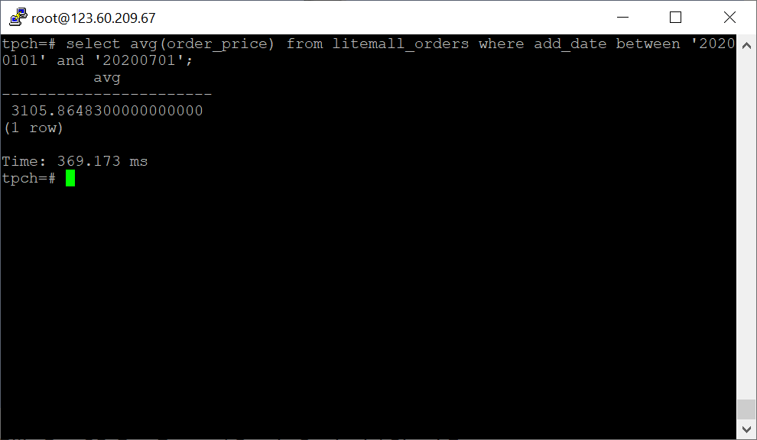

select avg (order_price) from litemall_orders_col where add_date between '20200101' and '20200701';

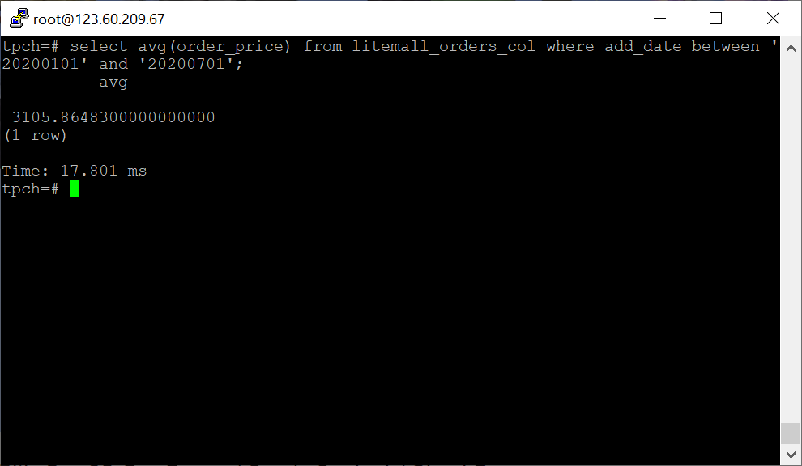

3. 查询litemall_orders行存表与litemall_orders_col列存表中order_id为6的order_price的值，并对比执行效率截图。

select order_price from litemall_orders where order_id=6;

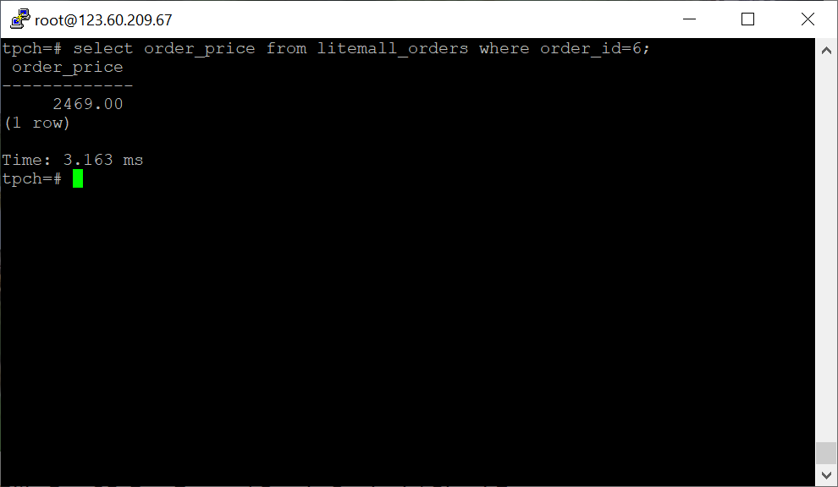

select order_price from litemall_orders_col where order_id=6;

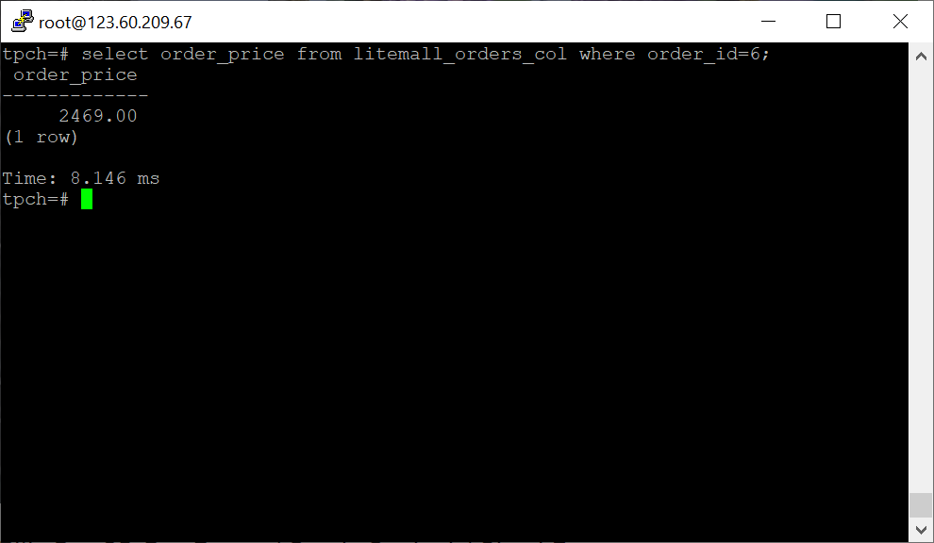

4. 将litemall_orders行存表与litemall_orders_col列存表中order_id为6的order_price修改为2468，并对比执行效率截图。

update litemall_orders set order_price=2468 where order_id=6;

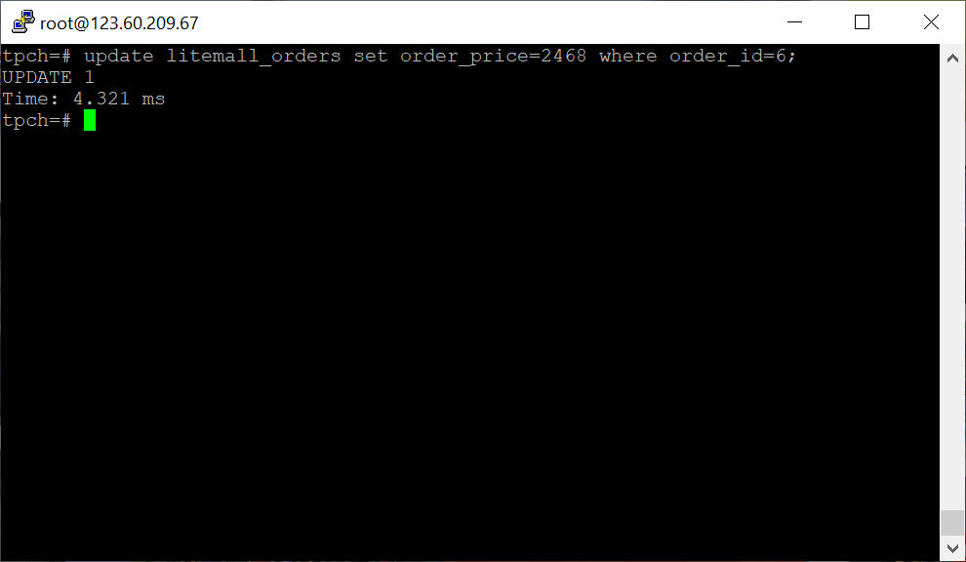

update litemall_orders_col set order_price=2468 where order_id=6;

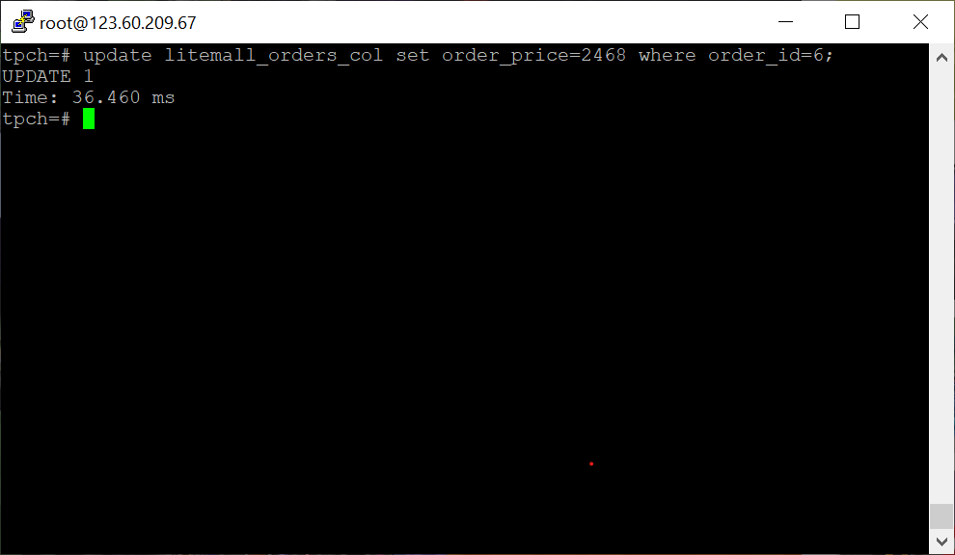

任务三：物化视图的使用

1. 创建物化视图所需要的表后，对表内容进行查询，对查询结果截图：

SELECT * FROM test_view;

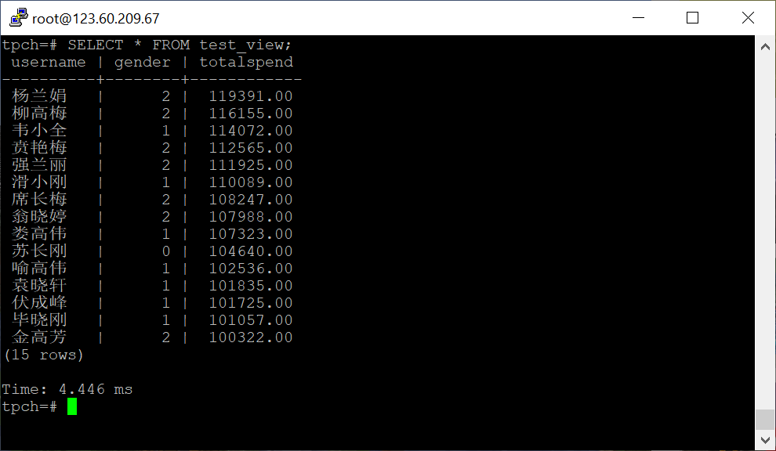

2. 使用物化视图统计人数，查询物化视图结果，将执行结果截图。

SELECT * FROM v_order;

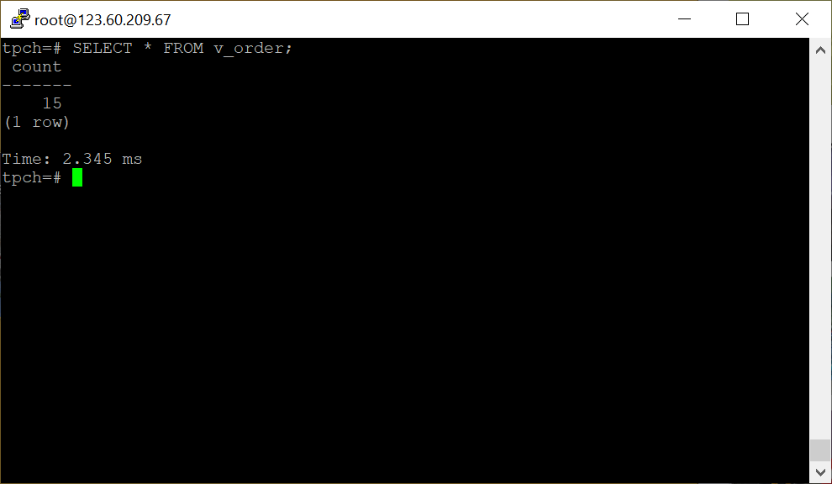

3. 对表进行操作后，刷新物化视图，查询物化视图结果，将执行结果截图。

SELECT * FROM v_order;

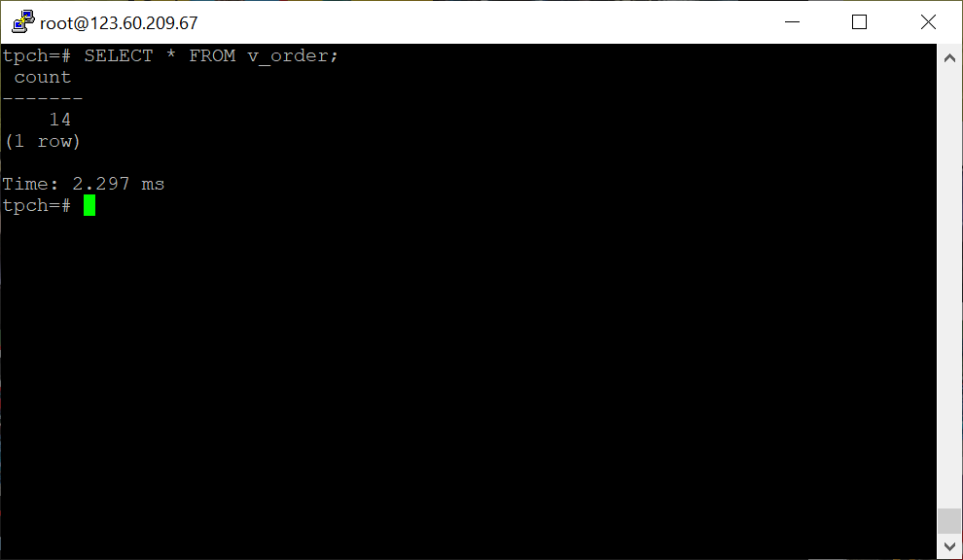

4. 创建增量物化视图，查询物化视图结果，将执行结果截图。

SELECT * FROM vi_order;

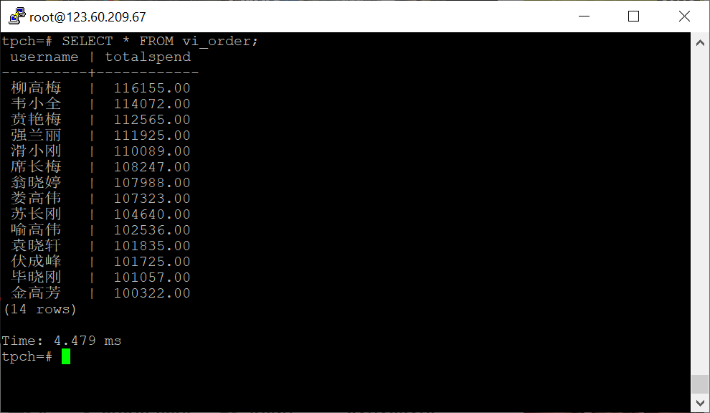

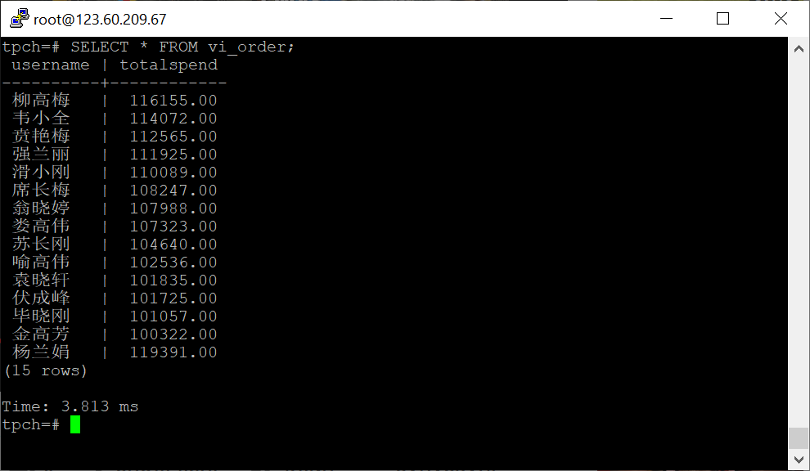

5. 对表进行操作后，刷新增量物化视图，查询物化视图结果，将执行结果截图。

SELECT * FROM vi_order;

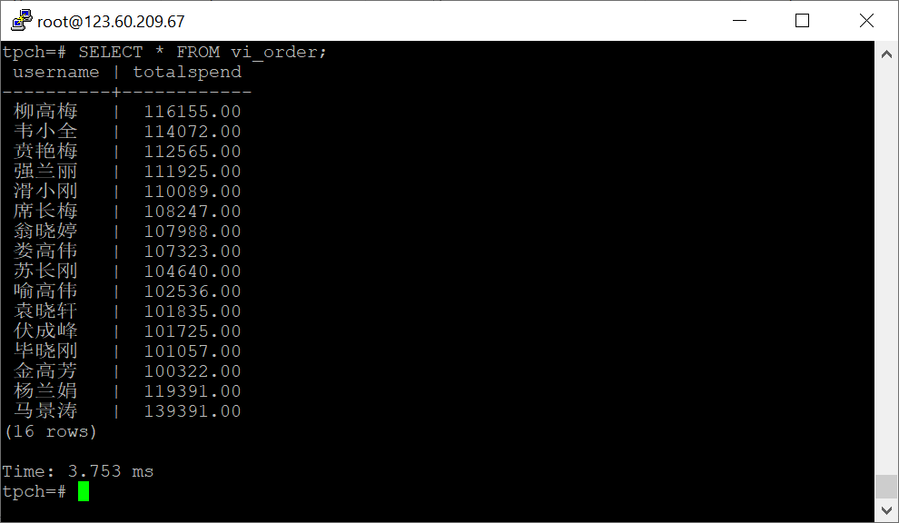

实践思考题1：行存表与列存表在执行相同的SQL语句时，为何执行的时间不同？在执行哪些类型SQL时，行存表效率更高？在执行哪些类型SQL时，列存表效率更高？

The writing and reading methods are different. When writing on row storage the process is competed at once and the data integrity can be determined. The writing of column storage has to split the rows into columns, which makes the number of writes grater, therefore slower.

When data is read, row storage usually reads a row of data completely, which may have redundancy; column storage reads one segment or all of the data each time, and there is no redundancy problem.

In conclusion, a row storage table is suitable for random addition, deletion, modification, and check operations, or the focus is on the entire table, and a column storage table is suitable for big data processing fields that do not require high data integrity.

实践思考题2：全量物化视图与增量物化视图有哪些差别？

Fully materialized views only support full updates to the created materialized views. It does not support incremental updates. Incremental materialized views, on the other hand, can incrementally refresh the materialized views, requiring users to manually execute statements to refresh the incremental data of the materialized views over a period of time.

# 关卡三、openGauss的AI4DB特性应用

任务一：使用X-Tuner进行参数优化

1. 执行TPCH脚本，获得测试时间，将执行结果截图：

gsql -d tpch -p 5432 -r -f /opt/software/tpch-kit/dbgen/queries/queries.sql > /opt/software/tpch-kit/dbgen/queries/queries01.log

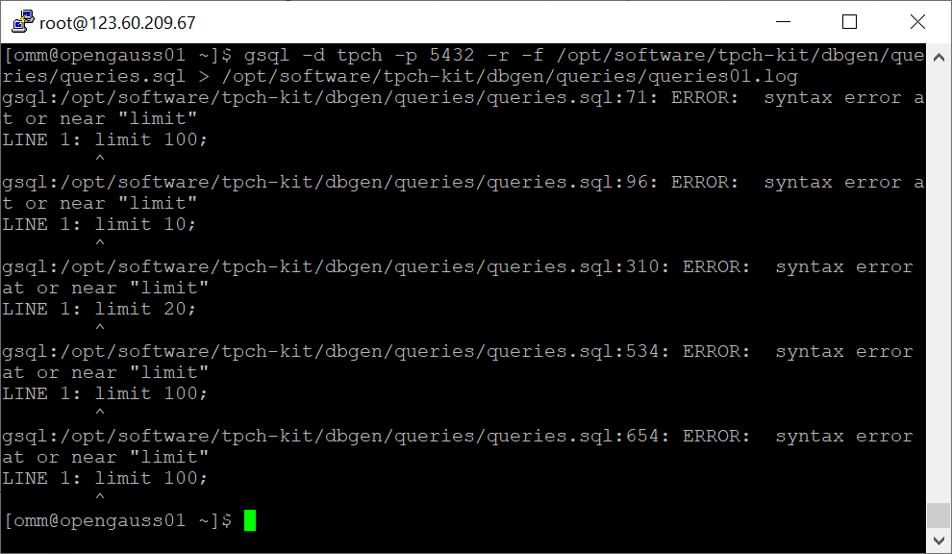

2. 使用root用户，执行X-Tuner进行参数建议优化，将执行结果截图

gs_xtuner recommend --db-name tpch --db-user omm --port 5432 --host 127.0.0.1 --host-user omm

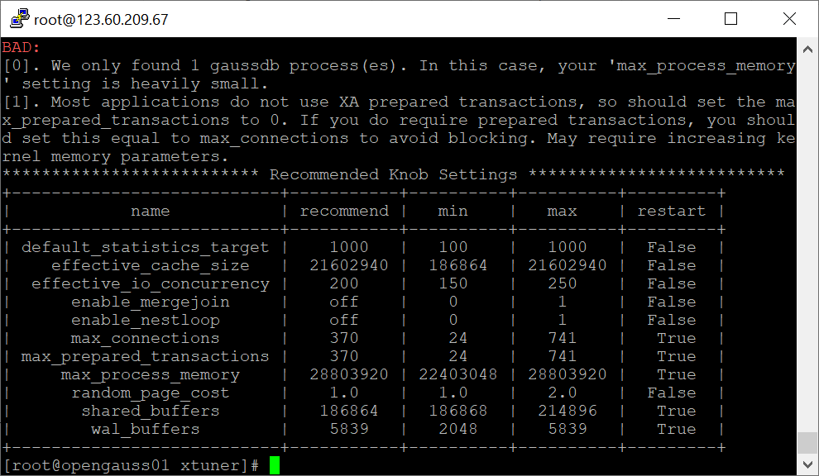

3.重启完成后，获取参数值：

cd /opt/software/openGauss/data

cat postgresql.conf|grep -E 'shared_buffers|max_connections|effective_cache_size|effective_io_concurrency|wal_buffers|random_page_cost|default_statistics_target'

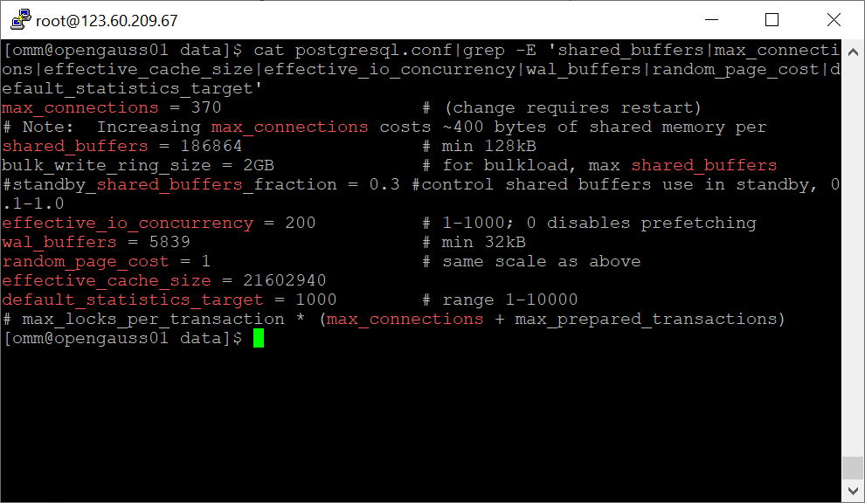

任务二：使用Index-advisor对select 查询语句进行优化，并通过对比执行计划，得到优化前后的不同。

1. 使用explain，对查询2020年3月订单表收入并进行排序的SQL加以分析，将结果截图。

EXPLAIN

SELECT ad.province AS province, SUM(o.actual_price) AS GMV

FROM litemall_orders o,

address_dimension ad,

date_dimension dd

WHERE o.address_key = ad.address_key

AND o.add_date = dd.date_key

AND dd.year = 2020

AND dd.month = 3

GROUP BY ad.province

ORDER BY SUM(o.actual_price) DESC;

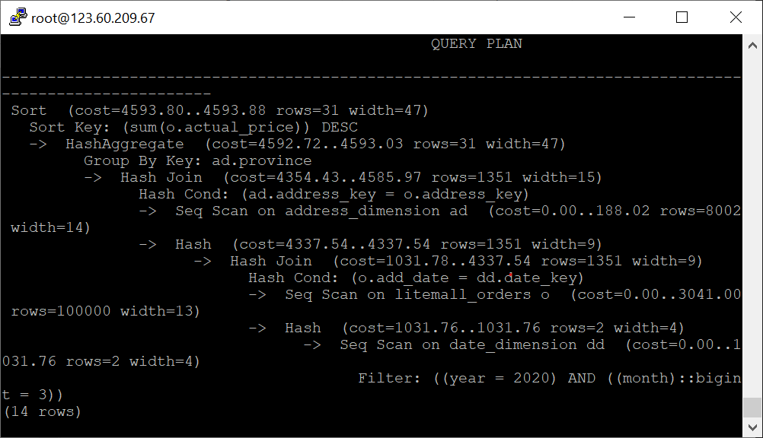

2. 使用索引推荐功能，对查询语句进行推荐，将执行结果截图。

select * from gs_index_advise('

SELECT ad.province AS province, SUM(o.actual_price) AS GMV

FROM litemall_orders o,

address_dimension ad,

date_dimension dd

WHERE o.address_key = ad.address_key

AND o.add_date = dd.date_key

AND dd.year = 2020

AND dd.month = 3

GROUP BY ad.province

ORDER BY SUM(o.actual_price) DESC');

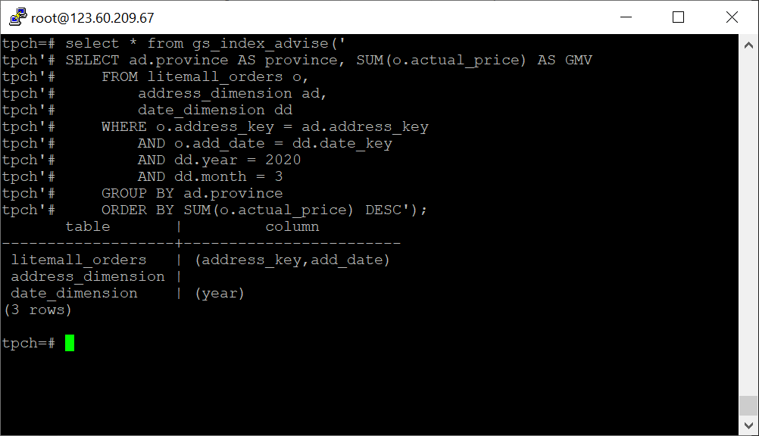

3. 查看创建的虚拟索引列，将执行结果截图。

select * from hypopg_display_index();

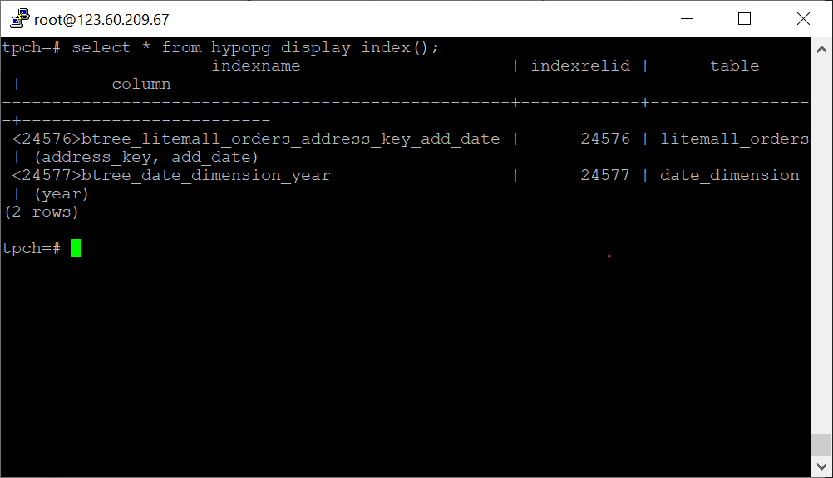

4. 获取索引虚拟列大小结果（单位为：字节），将执行结果截图。

select * from hypopg_estimate_size(16715);

select * from hypopg_estimate_size(16716);

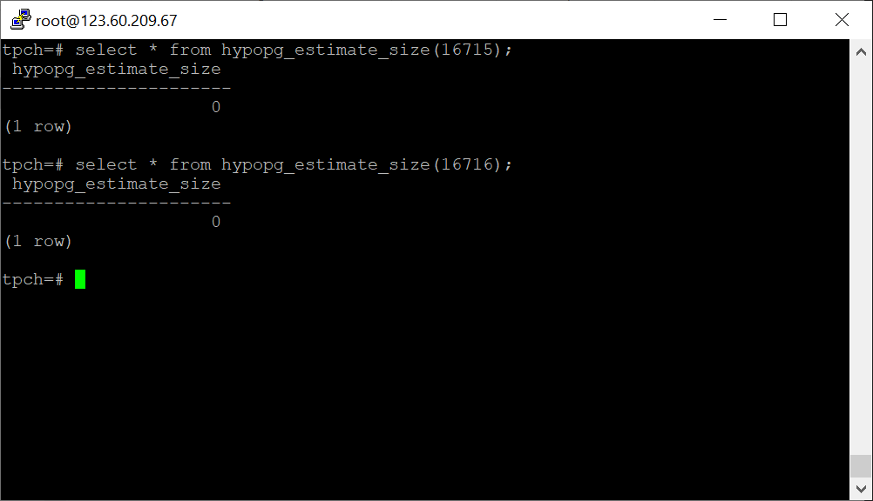

5.再次使用explain，对该SQL加以分析，将执行结果截图。

EXPLAIN

SELECT ad.province AS province, SUM(o.actual_price) AS GMV

FROM litemall_orders o,

address_dimension ad,

date_dimension dd

WHERE o.address_key = ad.address_key

AND o.add_date = dd.date_key

AND dd.year = 2020

AND dd.month = 3

GROUP BY ad.province

ORDER BY SUM(o.actual_price) DESC;

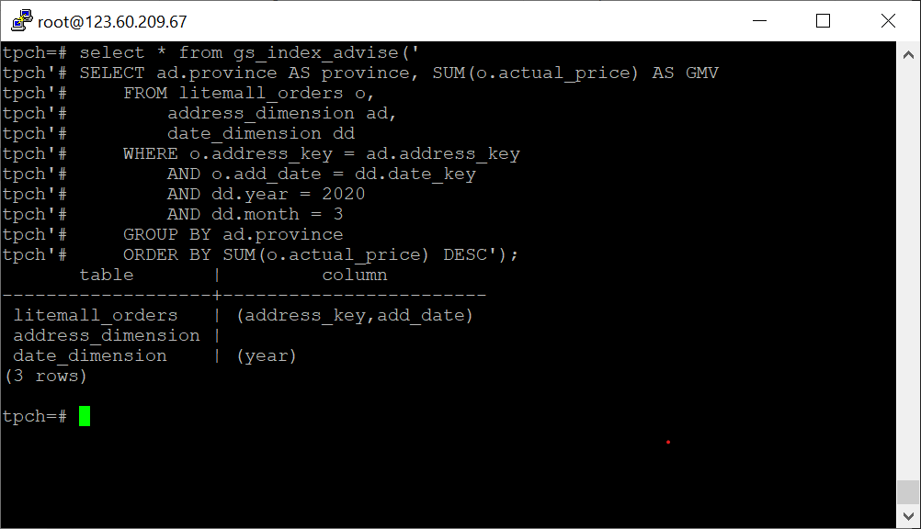

6. 删除某一个索引虚拟列，将执行结果截图。

select * from hypopg_drop_index(16715);

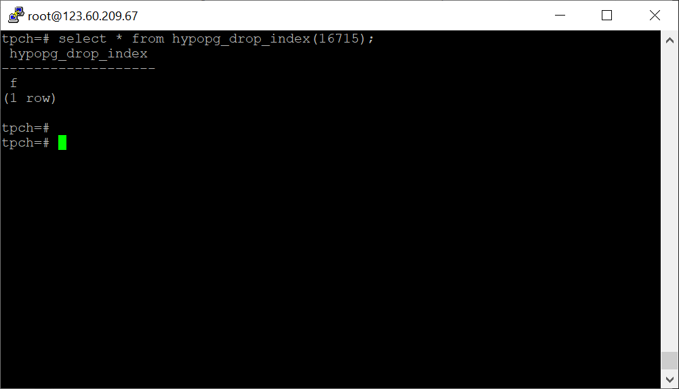

7. 删除某一个索引虚拟列，将执行结果截图。

select * from hypopg_reset_index();

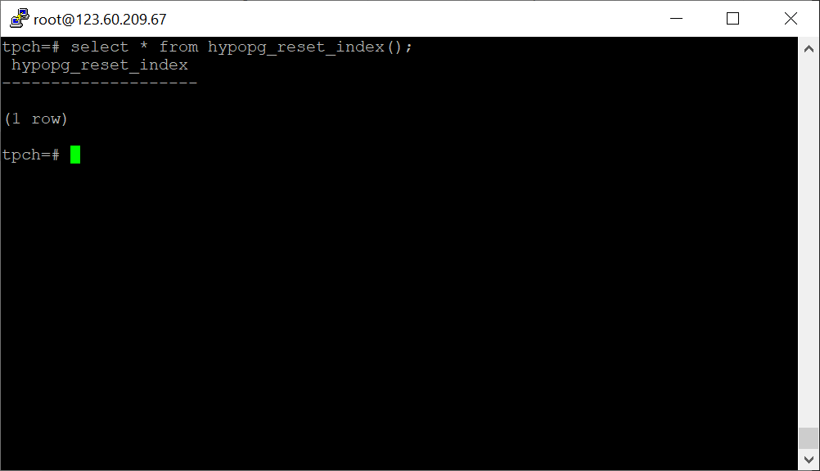

8. 查看索引虚拟列，将执行结果截图。

select * from hypopg_display_index();

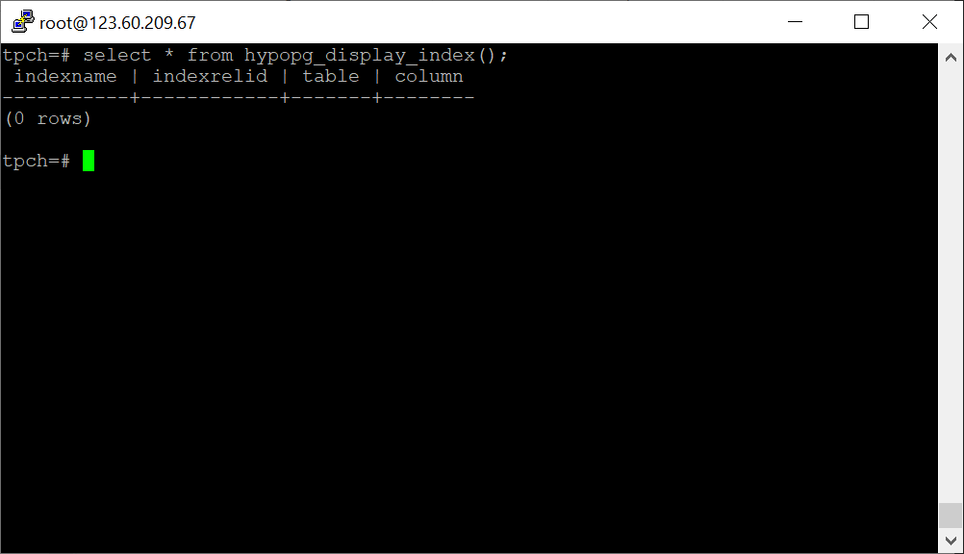

任务三：通过创建索引，对queries.sql中的SQL语句进行优化，并对比优化前后queries.sql执行的时间。

1. 重新执行queries.sql查询，将执行结果截图：

gsql -d tpch -p 5432 -r -f /opt/software/tpch-kit/dbgen/queries/queries.sql > /opt/software/tpch-kit/dbgen/queries/queries02.log

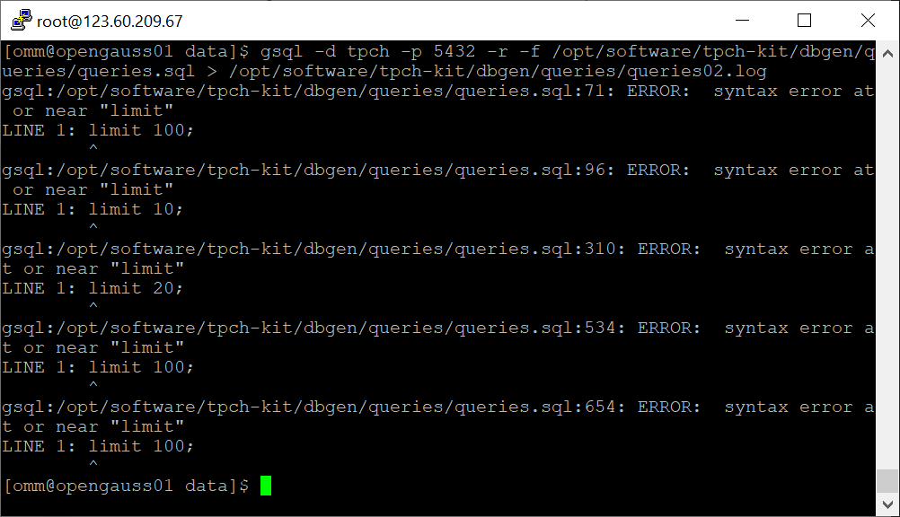

挑战一：进一步优化queries.sql中的查询语句，使得前后执行时间出现倍数级的提升。

1. 重新执行queries.sql查询，将执行结果截图：

gsql -d tpch -p 5432 -r -f /opt/software/tpch-kit/dbgen/queries/queries.sql > /opt/software/tpch-kit/dbgen/queries/queries03.log

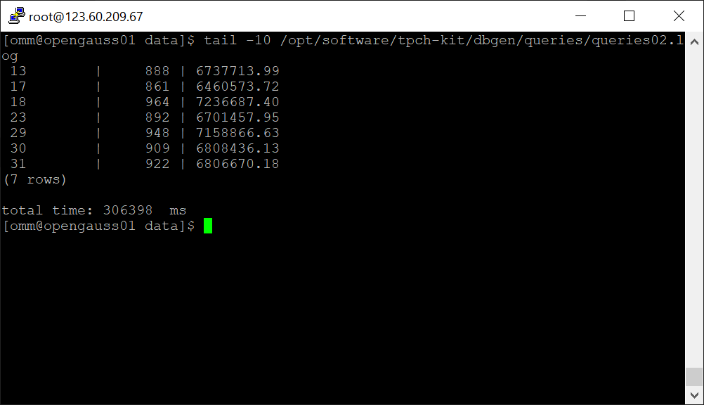

实践思考题1：根据X-Tuner给出的参数优化，在哪些参数上进行了优化，为何要对这些参数进行优化？

shared_buffer：In the database system, we mainly focus on disk IO, most of the oltp workload is random IO, so it is very slow to obtain from disk. OpenGuass caches data in RAM to improve performance.

wal buffer：The default size of the buffer is set by the wal_buffers setting-initially 16MB. If the system to be tuned has a large number of concurrent connections, the higher the value of wal_buffers, the better the performance.

effective_cache_size.

max_connections: This parameter should be set as large as possible when the server resources are sufficient to meet the needs of multiple clients connecting at the same time.

实践思考题2：索引的使用，对于执行SQL有什么好处？除了使用索引和参数外，还有哪些方面可以对数据库进行优化？

When a database executes a SQL statement, the default method is to scan the entire table according to the search conditions, and join the search result set when it encounters a matching condition. If we add an index to a field, the query will first locate the number of rows with a specific value in the index list at a time, greatly reducing the number of matching rows traversed, so the query speed can be significantly increased.

Optimized query statement, select the most applicable field attribute, use foreign keys, use JOIN instead of Sub-Queries, replace manually created temporary tables by using UNION;

# 关卡四、openGauss的DB4AI特性应用

任务一：在gs_model_warehouse系统表中查看训练后的模型信息，将执行结果截图：

postgres=# SELECT * FROM gs_model_warehouse WHERE modelname = 'house_binary_classifier'

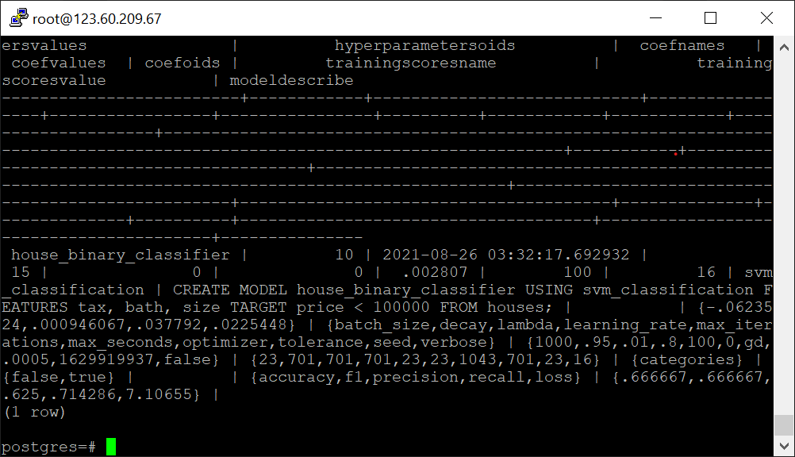

任务二：观察新模型的信息，将执行结果截图。

postgres=# SELECT * FROM gs_model_warehouse WHERE modelname = 'house_binary_classifier';

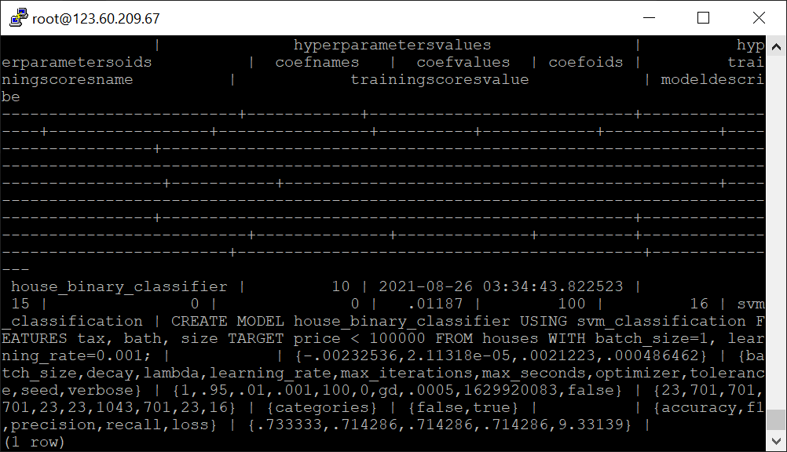

任务三：利用训练好的逻辑回归模型预测数据，并与SVM算法进行比较，将执行结果截图。

postgres=# SELECT tax, bath, size, price, price < 100000 AS price_actual, PREDICT BY house_binary_classifier (FEATURES tax, bath, size) AS price_svm_pred, PREDICT BY house_logistic_classifier (FEATURES tax, bath, size) AS price_logistic_pred FROM houses;

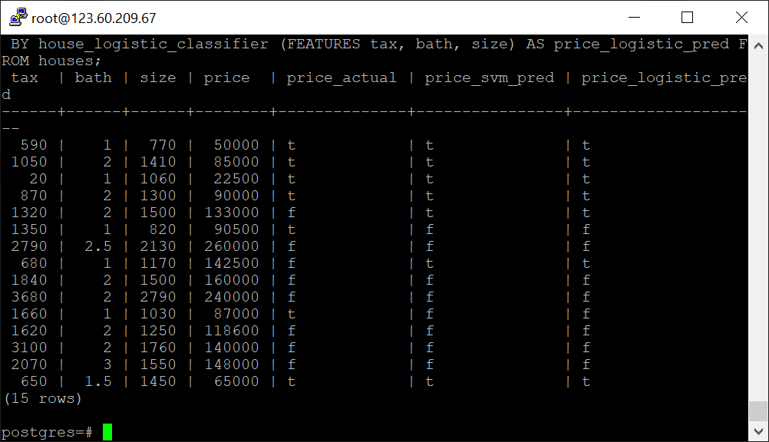

实践思考题1：分类模型与回归模型有何不同？

Classification outputs qualitative values; Regression outputs quantitative values

实践思考题2：什么是SVM算法？

Support Vector Machine(SVM) is a supervised machine learning algorithm used for both classification and regression. The algorithm is best suited for classification. The objective of SVM algorithm is to find a hyperplane in an N-dimensional space that distinctly classifies the data points. The dimension of the hyperplane depends upon the number of features. If the number of input features is two, then the hyperplane is just a line. If the number of input features is three, then the hyperplane becomes a 2-D plane. It becomes difficult to imagine when the number of features exceeds three.

Kernel trick. The kernel is a way of computing the dot product of two vectors x and y in some (very high dimensional) feature space, which is why kernel functions are sometimes called “generalized dot product. Kernel can be linear, polynomial,Radial basis function (RBF)/ Gaussian Kernel.

实践思考题3：分类问题有哪些评价指标，请分别说明他们的含义？

Accuracy: The accuracy of a machine learning classification algorithm is one way to assess how often model classifies a data point correctly. The numerator is total number of predictions that were correct. The denominator is the total number of predictions. The numerator will only include TP and TN and the denominator will be include TP, TN, FP, and FN. Accuracy is a ratio of the correctly classified data to the total amount of classifications made by the model.

Precision : Precision is the proportion of positive answers correctly predicated by the algorithm.

Recall: Recall is the proportion of actual positive answers given by the algorithm.

F1-score: The F-score, also called the F1-score, is a measure of a model’s accuracy on a dataset. It is used to evaluate binary classification systems, which classify examples into ‘positive’ or ‘negative’.

实践思考题4：回归问题有哪些评价指标，请分别说明他们的含义？

M.A.E (Mean Absolute Error): Returns the mean of difference between actual & predicted values.

M.S.E (Mean Squared Error): Takes the average of the square of the error. Where, the error is the difference between actual & predicted values.

R.M.S.E (Root Mean Squared Error): It squares the error & then it takes the square root of the total average function.

R — Squared(Relative Squared Error): This method helps us to calculate the relative error. This technique helps us to judge, which algorithm is better based on their mean squared errors.